Chapter 16, Solution 65.

For the RLC circuit shown in Fig. 16.88, find the complete response if v(0) = 2 V when the switch is closed.

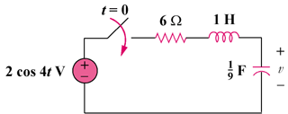

Figure 16.88
For Prob. 16.65.

Solution

For , the circuit in the s-domain is shown below.

s

2/s

9/s

6
+

(2s)/(s² + 16)
+

I

+

V

Applying KVL,

Equating coefficients :
: (1)
: (2)
: (3)
: (4)
: (5)

Solving equations (1), (2), (3), (4) and (5) gives
, , , ,

{2.202e^{-3t} + 3.84te^{-3t} – 0.202cos(4t) + 0.6915sin(4t)}u(t) V

